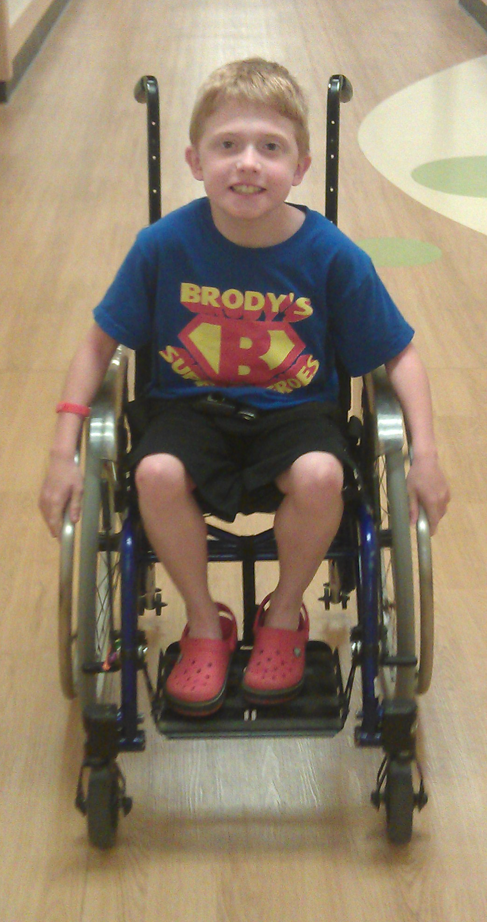
Brody’s Superheroes 5k Run/Walk
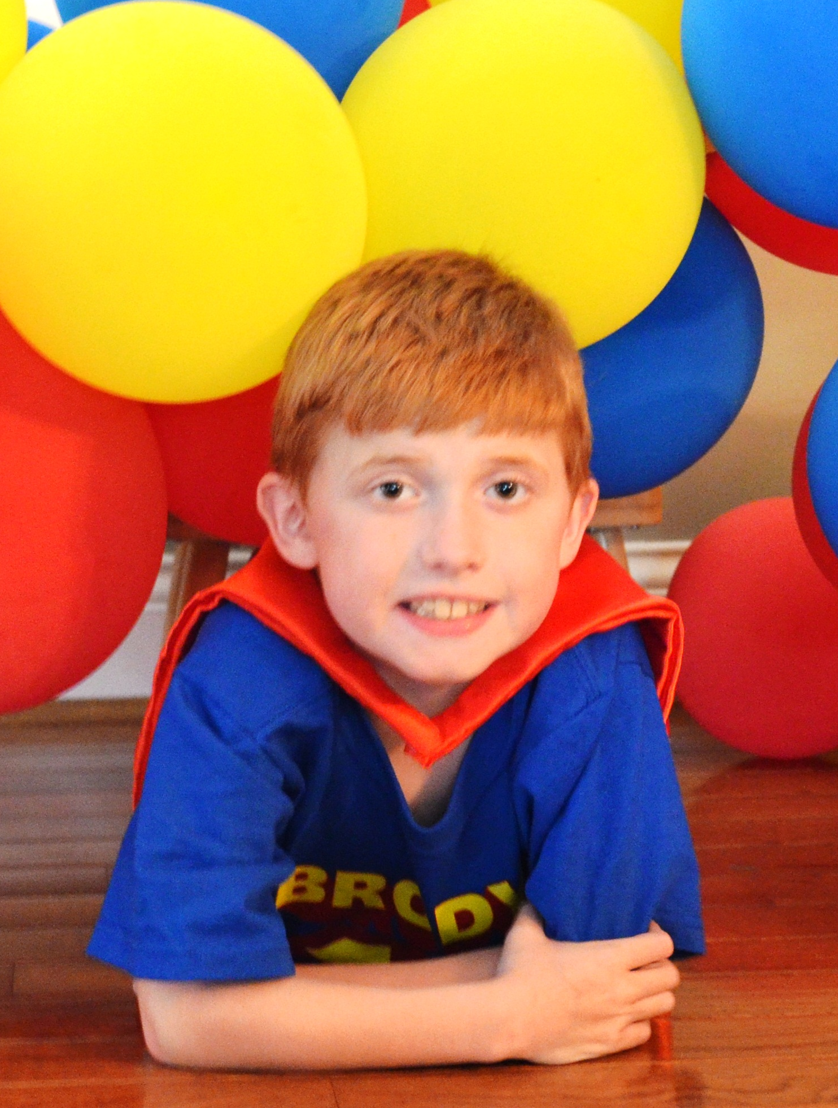
1 Mile Kids Fun Run/Walk

Saturday, June 7, 2014
9:00am
Endeavor Elementary School

Brody Hammons is a strong, spirited 9 year old boy fighting Duchenne Muscular Dystrophy, a fatal muscle disease with no cure. He is a third grader at Endeavor Elementary and loves playing with his brothers and sisters, playing video games, being a cub scout and being involved with sports. Brody is in the fight of his life as there is a drug that has the potential to save his life but it is pending FDA approval. All proceeds will go to two non-profit organizations, Charley’s Fund and Parent Project Muscular Dystrophy, as they fight to save Brody and boys like him. For more information on the fight to find a cure for Duchenne, please visit www.charleysfund.org and www.parentprojectmd.org.

$25 Adult Registration; $15 Youth Registration (12 and Under); Under 3: Free
Registration includes T-shirt, Food, Drinks & Kid-Friendly Activities

Packet pick up: 4 – 6pm at Endeavor on June 6th or beginning at 8am on June 7th

1 Mile Kids Run/Walk: 9am start
5K Run/Walk: 9:05am, start and finish at Endeavor Elementary, winding around Villages of Providence

Prizes will be awarded to top youth finishers.
(Please complete a separate registration form for each participant.)

Name: _________________________________________________ Gender: M F Age: _________

Address: _____________________________________ City, State, Zip: ____________________________

Phone: ___________________________ Email: ________________________________________________

Participant Status: 5K Run/Walk ____ 1 Mile Kids Run/Walk____ Unable to attend/Brody’s Superheroes Supporter _____

Shirt Size: YS YM YL AS AM AL AXL AXXL

Waiver (must be signed) In consideration of the acceptance of my entry, I, for myself, my executors, administrators, and assignees, do release, discharge, and hold harmless Brody’s Superheroes, Villages of Providence HOA, West Chester Township, Lakota Schools, their representatives, officials, volunteers, members and sponsors, from any and all claims, damages, demands or causes of action whatsoever in any manner directory or indirectly arising out of or related to my participation in said athletic event. I am physically fit and have sufficiently trained to participate in this event. I agree to abide by all the rules of participation.
Make Checks Payable to: Brody’s Superheroes. Mail to: Carrie Sitarski, 6983 Stratton Court, Liberty Twsp, OH 45011
I would like to make an additional donation to Charley’s Fund or Parent Project Muscular Dystrophy: $__________________

Participant’s Signature: _____________________________________________________________________________________ Date: ______________________

Parent’s Signature (for a minor less than 18 years of age): ______________________________________________________________________________

In case of emergency contact: _______________________________________________________________________________________________________________
Please return by May 25th! Thank you!
This material was prepared by Brody’s Superheroes and is not sponsored by the Lakota Local School District or any Lakota School.

