Brody’s Superheroes 5k Run/1 mile Family Walk
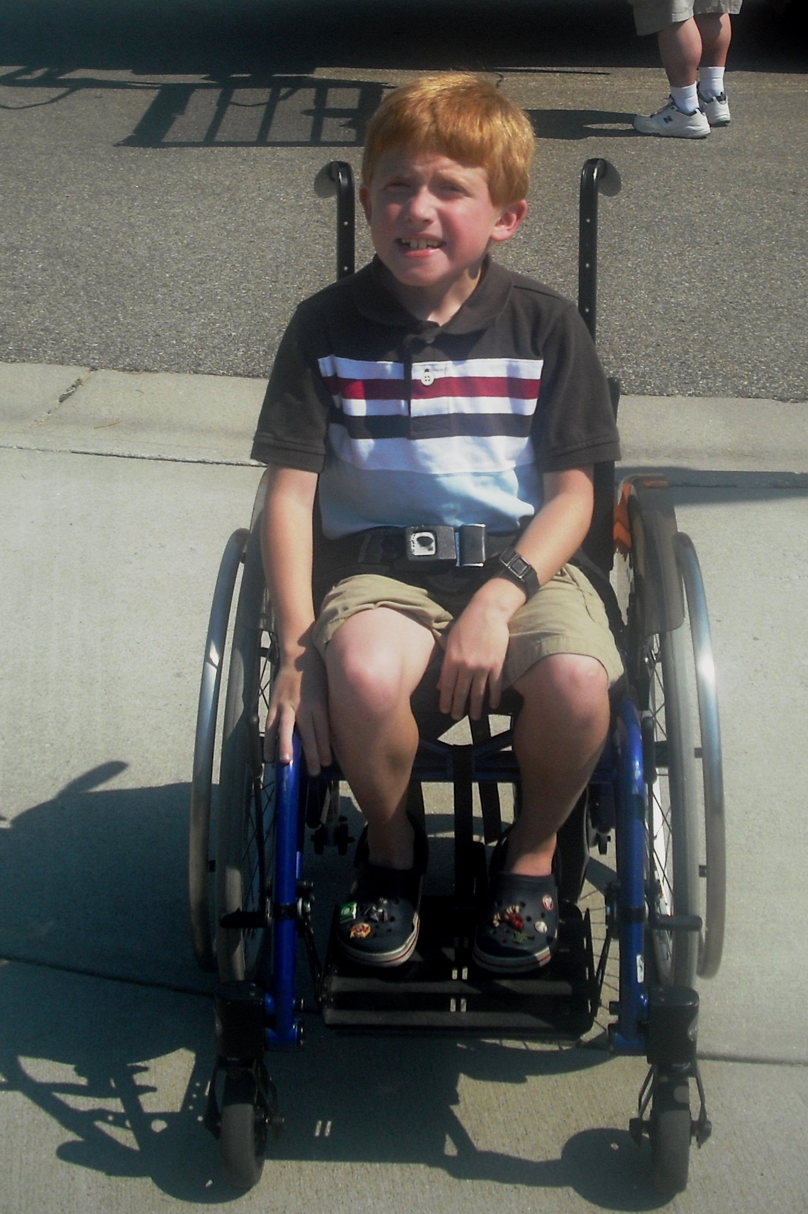
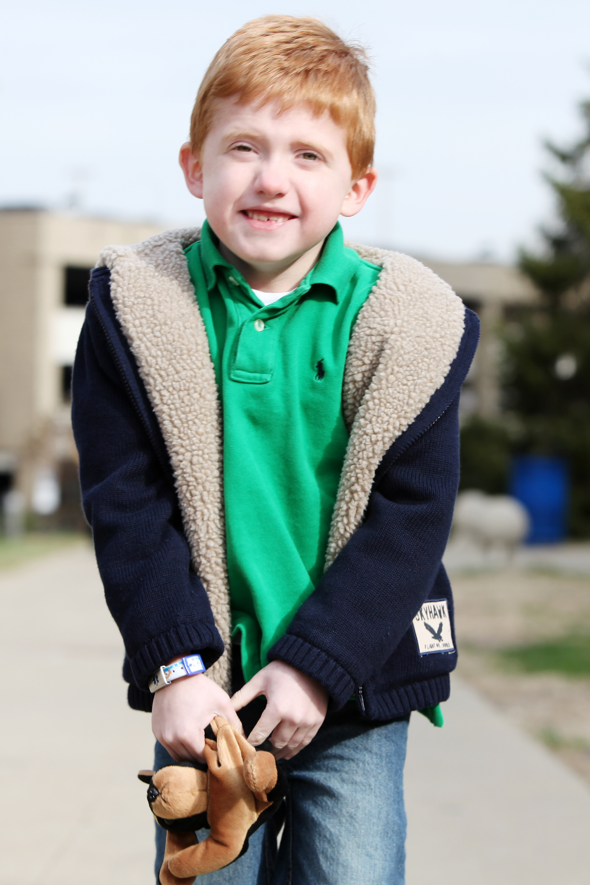
Saturday, June 8, 2013
9:00am
Endeavor Elementary School
4400 Smith Road, West Chester, Ohio 45069

Brody Hammons is a strong, spirited 8 year old boy fighting Duchenne Muscular Dystrophy, a fatal muscle disease with no cure. He is a second grader at Endeavor Elementary and loves playing with his brothers and sisters, playing video games, being a cub scout and being involved with sports. All proceeds from the race will go to pay his medical bills and therapy as well as support Parent Project Muscular Dystrophy. For more information on Parent Project and their fight to find a cure for Duchenne, please visit www.parentprojectmd.org.

Individual Entry includes a T-shirt and Food.
$25 Adult Registration; $15 Youth Registration (12 and Under); Under 3: Free

Packet pick up: 4 – 6pm at Endeavor on June 7th or beginning at 8am on June 8th.

5k: 9am, start/finish at Endeavor, around Villages of Providence subdivision
1 mile Family Walk: 9:10am, start/finish at Endeavor, winding through VOP
(Please attach info or use multiple forms for Family Registration.)

Name: __________________________________________________________________ Age: _________

Address: _____________________________________ City, State, Zip: ____________________________

Phone: ___________________________ Email: ________________________________________________

I would like to make an additional donation to Brody’s Superheroes: $______________________
I would like to make an additional Tax Deductible Donation to Parent Project: $___________________

Gender: M F Runner ___ Walker ___ Vacation/Sleep-in (unable to make race day)___
Shirt Size: YS YM YL AS AM AL AXL
Make Checks Payable to: Brody’s Superheroes and mail to: 4255 North Shore Drive, West Chester, OH 45069

Waiver (must be signed) In consideration of the acceptance of my entry, I, for myself, my executors, administrators, and assignees, do release, discharge, and hold harmless Brody’s Superheroes, Villages of Providence HOA, West Chester Township, Lakota Schools, their representatives, officials, volunteers, members and sponsors, from any and all claims, damages, demands or causes of action whatsoever in any manner directory or indirectly arising out of or related to my participation in said athletic event. I am physically fit and have sufficiently trained to participate in this event. I agree to abide by all the rules of participation.

Participant’s Signature: _____________________________________________________________________________________ Date: ______________________

Parent’s Signature (for a minor less than 18 years of age): ______________________________________________________________________________

In case of emergency contact: _______________________________________________________________________________________________________________

